**what is php ?**

php is a server side scripting language

php is used to make dynamic application and website.

Php first time release in 1984 by rasmus landroef

In 1984 php stands for personal home page

After 1986 php further updated and stands for php:hypertext preperocessor

Php is open sourse language it meanse used without purchase licence

Ex: php , java , react js , android etc.

Php is support all database

Ex: mysql , oracle, sqllite, sql server .

Php support all server

Ex: apache , tomcat , iis

Php used to load data on server and exute on server

Ex: apache

Php hypertext preprocessor

Examples.php

<!DOCTYPE html>

<html>

<head>

    <meta charset='utf-8'>

    <meta http-equiv='X-UA-Compatible' content='IE=edge'>

    <title>Page Title</title>

    <meta name='viewport' content='width=device-width, initial-scale=1'>

    <link rel='stylesheet' type='text/css' media='screen' href='main.css'>

    <script src='main.js'></script>

</head>

<body>

    <?php

     $name="hello i am Brijesh";

     echo $name;

    ?>

</body>

</html>

Php is a loosly type of language

Ex: php does not start any variables with its datatype

$name=”Brijesh”;

$a=10;

$c=1545.5454;

Php is start and closed that is called delemter in php

a) Standard deleter

<?php

Statements;

?>

b) direct output delemeters

<?=

Statements;

?>

Php file extention should be .php , .php3 , .phtml but standard is .php

Php support on all operating

Ex: windows family , ubuntu, linux , ios, android etc

Php support some server tools that are

Xampp

X=>coss plateform support all OS

A=>apache

M=>Mysql

P=>perl support procedural base language

p=>php

WAMP

w=>windows

A=>apache

M=>Mysql

p=>php

LAMP

L=>Linux os

A=>apache

M=>Mysql

p=>php

XAMPP : xampp default server port is 80

<http://localhost/php430mwf/module3/corephp/php%20delemeters/direct_output.php>

<https://localhost/php430mwf/>

how to change xampp port number and run php

step : open .httpd.config file and change port number

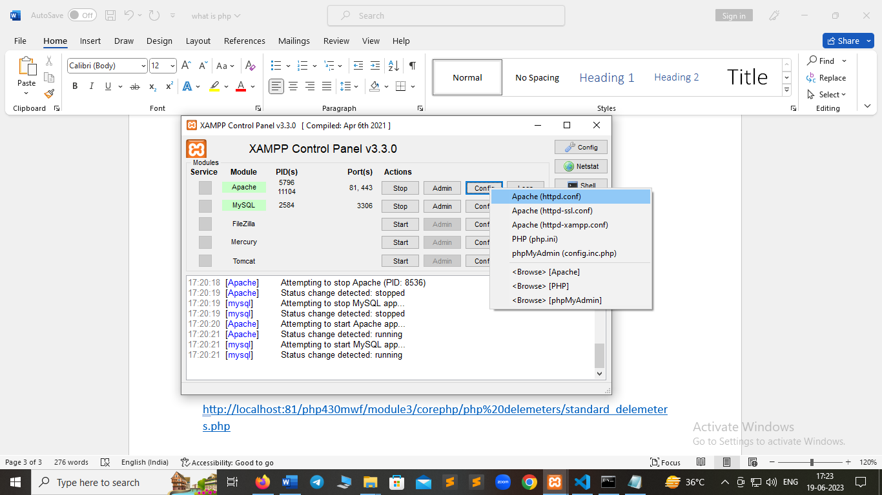

<http://localhost:81/php430mwf/module3/corephp/php%20delemeters/standard_delemeters.php>

**a) php operator** :

operator is operand some acctions using operator

a) airthmatic operator

ex: +, -, *, /, % etc.

b) assignment operator

ex: =, ==, != , +=, -=, *=etc.

c) comparision operator

ex: >, <, >=, <=, ===

d) logical operator

ex: && , and , or , || , ! , not

e) ternary operator

ex: ?:

f) string concatenate operator

ex: .

g) increment/decrement operat

ex: ++ , --

$ i++; post increment

$i--; post decrement

--$i; pre decrement

++$i; pre increment

**What Php variables :**

A variable is just like container where we stored a data informations**.**

**Or**

A variable is stored an information about data i.e called variable

Variables denoted by $ symbol in php

**Rules of variables in php**

a) php does not start a variable with numeric

7$a; //wrong

$a7 //right

b) php never take a variables start with underscore

_$a; wrong

c) variables does not have space

$a b; wrong method

$ab; right

d) variables does not start with reserved keyword

$for; //wrong

Note : $a=10; $name=”brijesh”; $c=”hey”;

$$a=10; reference variables